# Project: Analyzing a Market Test

## Step 1: Plan Your Analysis

*To perform the correct analysis, you will need to prepare a data set. (500 word limit)*

*Answer the following questions to help you plan out your analysis:*

1. What is the performance metric you’ll use to evaluate the results of your test?

Gross margin.

1. What is the test period?

29 April 2016 to 21 July 2016.

1. At what level (day, week, month, etc.) should the data be aggregated?

Weekly.

## Step 2: Clean Up Your Data

*In this step, you should prepare the data for steps 3 and 4. You should aggregate the transaction data to the appropriate level and filter on the appropriate data ranges. You can assume that there is no missing, incomplete, duplicate, or dirty data. You’re ready to move on to the next step when you have weekly transaction data for all stores.*

## Step 3: Match Treatment and Control Units

*In this step, you should create the trend and seasonality variables, and use them along with you other control variable(s) to match two control units to each treatment unit. Note: Calculate the number of transactions per store per week to calculate trend and seasonality.*

*Apart from trend and seasonality...*

1. What control variables should be considered? Note: Only consider variables in the RoundRoastersStore file.

Average Monthly Sales and Square Footage should both be considered.

1. What is the correlation between your each potential control variable and your performance metric?

The AvgMonthSales is highly correlated with Gross Margin while the Sq_Ft has a very small correlation with Gross Margin.



1. What control variables will you use to match treatment and control stores?

AvgMonthSales, Trend and Seasonality will be used

1. Please fill out the table below with your treatment and control stores pairs:

|  |  |  |
| --- | --- | --- |
| Treatment Store | Control Store 1 | Control Store 2 |
| 1664 | 7162 | 9238 |
| 1675 | 11818 | 9968 |
| 1696 | 11668 | 12169 |
| 1700 | 10068 | 2902 |
| 1712 | 10018 | 8162 |
| 2288 | 1580 | 2568 |
| 2293 | 8262 | 12686 |
| 2301 | 1964 | 12019 |
| 2322 | 3235 | 9388 |
| 2341 | 2572 | 3102 |

## Step 4: Analysis and Writeup

*Conduct your A/B analysis and create a short report outlining your results and recommendations. (250 words limit)*

*Answer these questions. Be sure to include visualizations from your analysis:*

1. What is your recommendation - Should the company roll out the updated menu to all stores?

The average lift is 44.7% (>18%) and the expected increase in gross margin by $757.10. Therefore, yes the company should roll out the updated menu to all of its stores

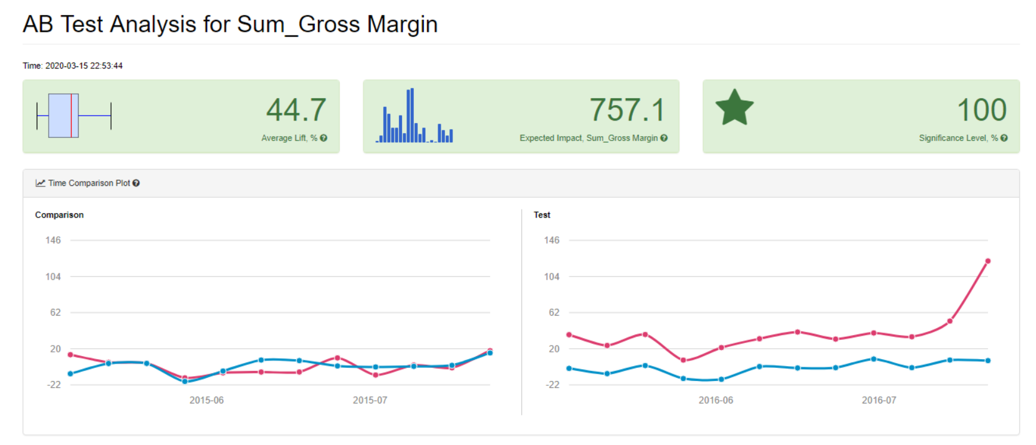

1. What is the lift from the new menu for West and Central regions (include statistical significance)?

Central: 54.6% lift with 99.7% significance (very high).

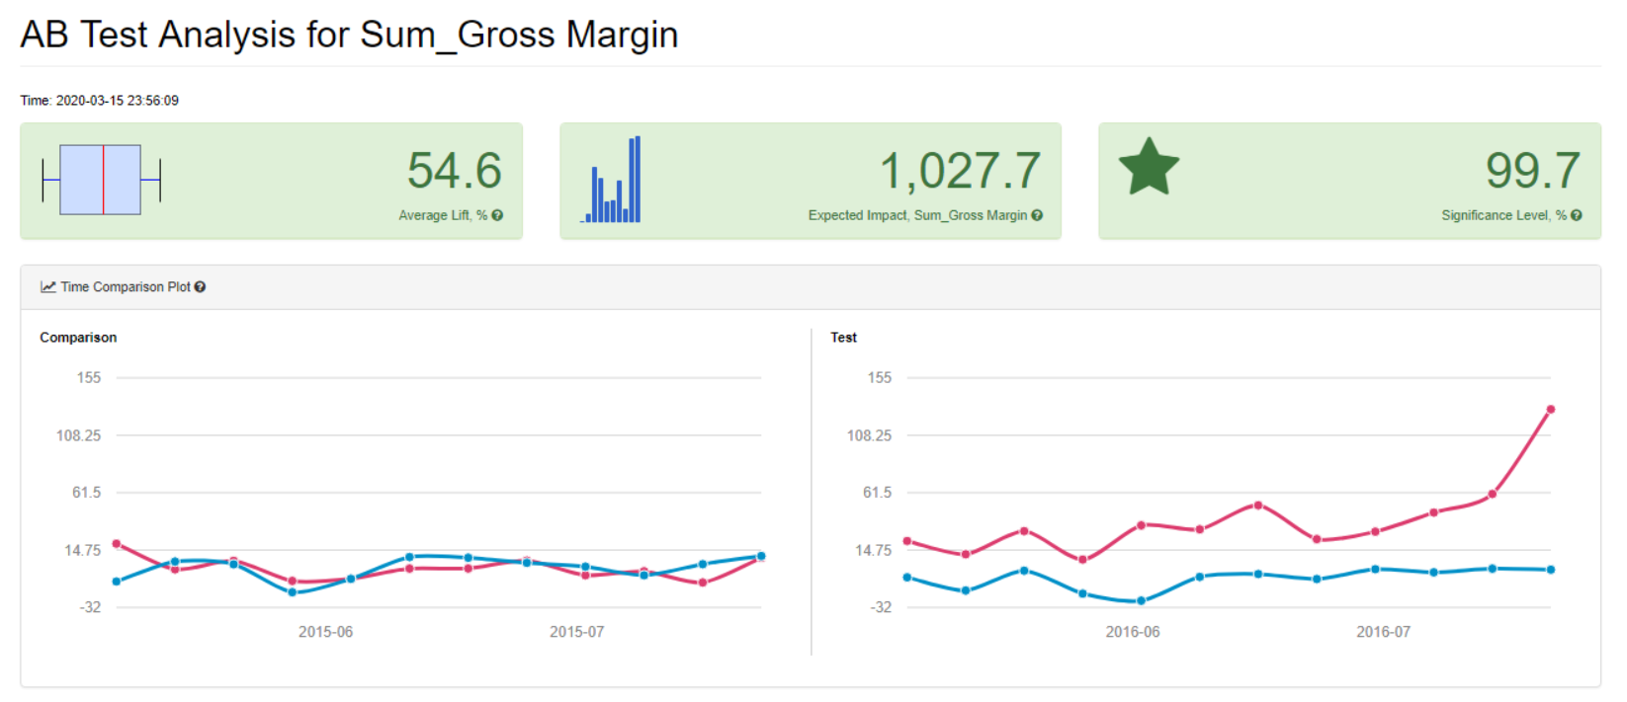

West:34.9% lift with 99.3% significance (very high).

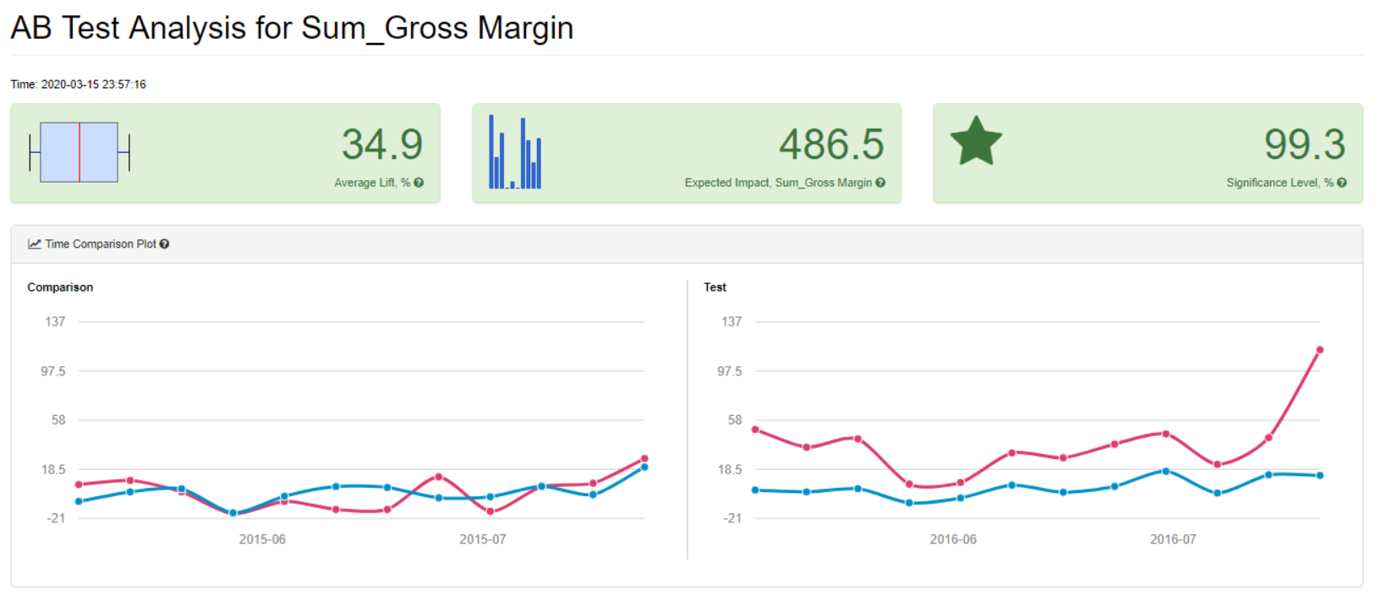

1. What is the lift from the new menu overall?

The overall lift from the new menu is 44.7%.

Alteryx Workflow

